**Grade One Phonics Worksheets**

**Monday May 11th, 2020**

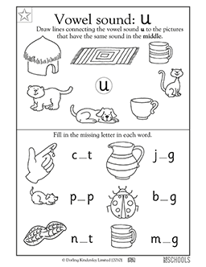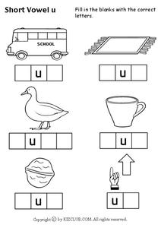

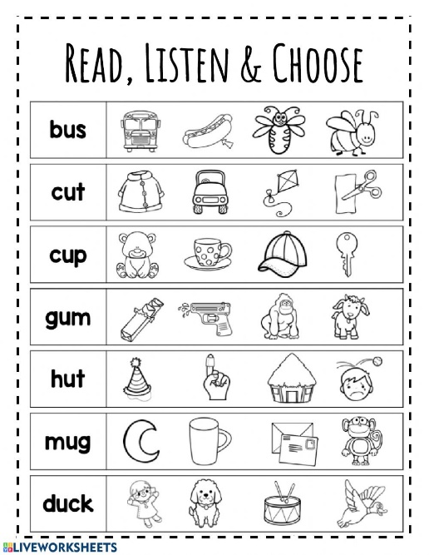

<https://www.youtube.com/watch?v=i81NmRz4nu0>

Grammar Worksheets for Grade One

Wednesday May 13th, 2020

Read the sentences. Put a tick in the box next to the sentence that ask a question.

<https://www.youtube.com/watch?v=vXWK1-L41f0>

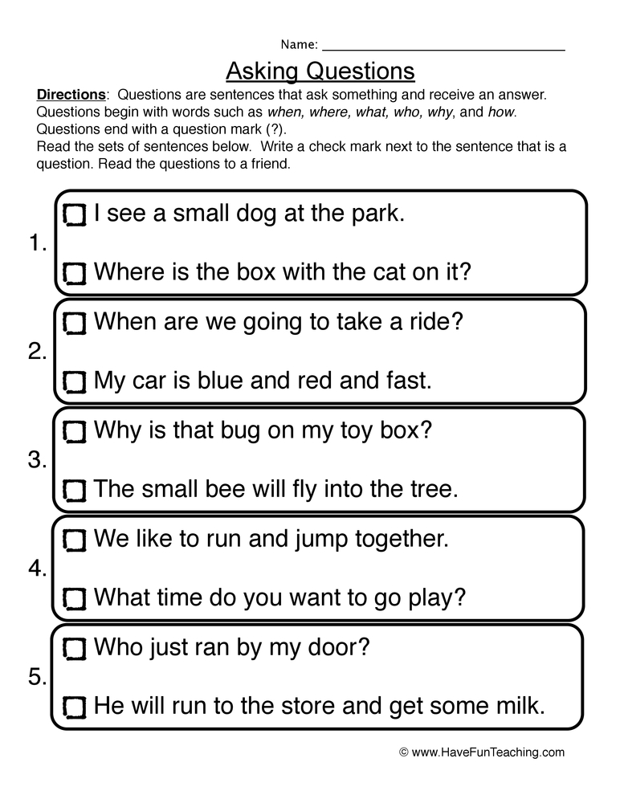

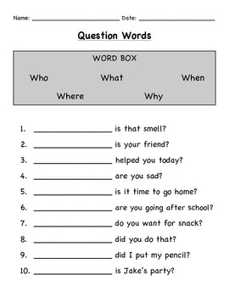

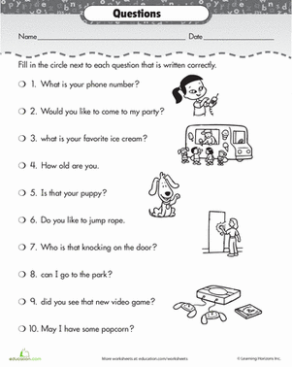

**Friday May 15th, 2020**

**Assessment Exercises**

